Team 11
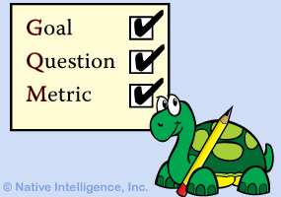GOAL QUESSTION METRIC For VIKING PROJECT- GQM
SOFTWARE MEASUREMENT AND ANALYSIS

Create by: Team 11
5/26/2012

Table of contents
1. Purpose 2
2. Goal Question Metric diagram 2
List of figures
Figure 1 2
List of tables

Purpose
This document provides to update the information about measurement in Viking Project to support PM make decision to meet business goals of project

Goal Question Metric diagram
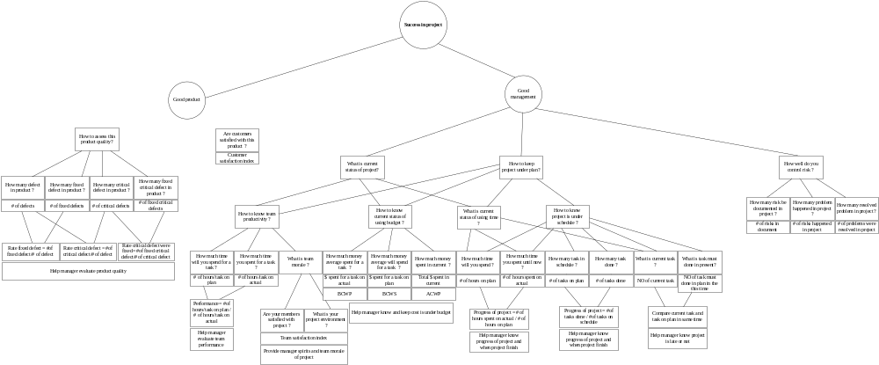
Figure 1
References attachment file:
“GQM For VKP Diagram”

